

Curriculum Vitae Europass |  | 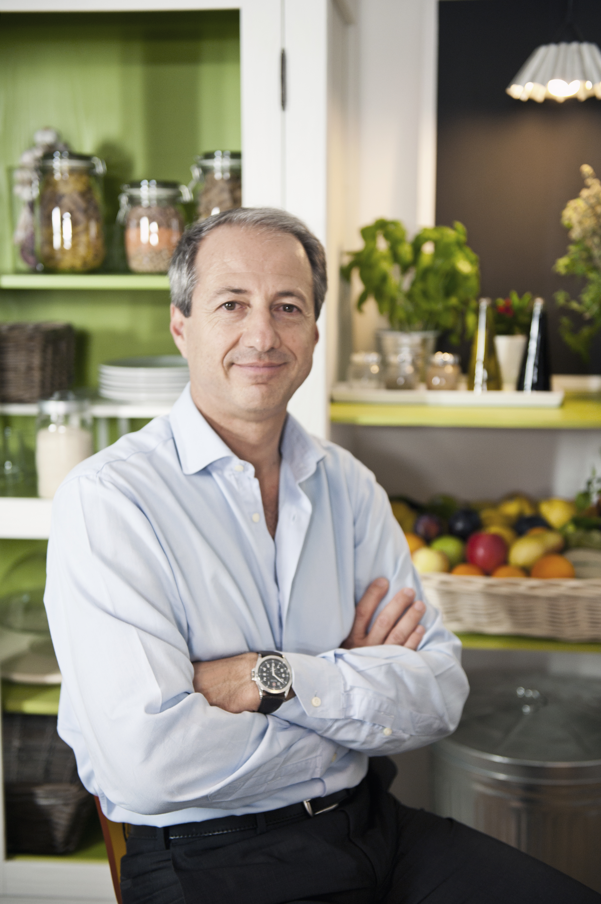
PERSONAL INFORMATIONS
Surname / Name |  | Piretta Luca
Address |  | Via Saint Vincent 35 , 00135 ROMA
Telephone |  | 06/3017194 06/33625650 | Mobile: | 347 2601870
Fax
E-mail |  | pirets@tiscali.it
Citizenship |  | Italiana
Date of birth  City |  | 24/02/1961  Torino
Sex |  | male
Profession  Professional Field |  | Medical Doctor  Gastroneterology, Nutrition
PROFESSIONAL EXPERIENCE
Date |  | Since July 2010 to March 2013
Working position |  | Adjunct Professor of “Nutrition in gastroenterology” at Scuola di Specializzazione di Gastroenterologia
Institute  Date  Working position |  | Sapienza, Università di Roma  Viale del Policlinico, 00161 Roma  Since 2011  Adjunct Professor of “Nutrition in Digestive diseases “ and “Alimentary Allergies and Intolerances” in University Degree Course of “Scienze dell’Alimentazione e della Nutrizione Umana”  At Università Campus Bio-medico di Roma
Institute  Date |  | Università Campus Biomedico di Roma  Via A. del Portillo 21 00128 Roma  Since 2002
Working position  Insitute |  | Tutor at Scuola di Specializzazione di Gastroenterologia
Sapienza, Università di Roma
Viale del Policlinico, 00161 Roma

Date  Working position  Date  Working positioni  Date  Working positioni |  | Since 1995  General Practitioner  Since1991  Clinical gastronterologist highly skilled in esphageal diseases (manometry and pH-metry)  Since 1994  Clinical Nutritionist
Date  Date  Working position  Data  Working position  Date |  | M  Since 1987  Participation as speaker at numerous national and international congresses in the field of gastroenterology and Nutrition.  Since 1996  Rai Consultant.  Regular participation in national television programs (RAI, mediaset and La7) as a consultant guest expert in the fields of gastroenterology and nutrition.  Consultant for the MelarossaTV website and for the magazine "Sano e Leggero" edited by RCS. Numerous interviews and articles on national newspapers and paper and online dissemination journals on topics related to nutrition and gastroenterology  2002  Member of the editorial board of the magazine CIBUS  1987-2017  Author of more than 50 scientific publications on national and international journals and chapters of scientific books
Date  Working position  Education and training  date |  | 2014  Member of the scientific committee of the magazine L’Affidabile (Assolatte)  2008
Qualification |  | Masters Degree in Science of Human Nutrition  110/11elode (full marks with honors)
Main themes / professional skills |  | Techniques for Study and Evaluation of Human Nutrition. Knowledge of basic sciences in the biochemical, genetic, legal, epidemiological field of nutrition
Institution  Date  Qualification  Institution  Date  Qualification  Institution  Date  Qualification  Institution  date  Qualification |  | University di Tor Vergata, Rome  1997-1998  Master in Nutrition and Dietary Therapy  Medical school of Rome and Lazio  1994  Master in Prevention and Therapy of Obesity and Other Conditions of Malnutrition  University “La Sapienza “ of Rome  1991-1992  Traineeship as General Practitioner  50/5(full marks)  Regione Lazio  1991  Post-graduate Specialization Diploma in Gastroenterology and Digestive Endoscopy  70/70 e lode (full marks with honors)
Main themes / professional skills  Institution |  | Particular competence in the study of functional diseases of the gastrointestinal tract. He has conducted research and publications related to the study of esophagus (reflux disease, acalasia) and colon (irritable bowel syndrome) allergies and food intolerances. He has acquired expertise with diagnostic methods such as oesophageal manometry and esophageal pH metry  University La Sapienza of Rome
Date  Qualification  Institution  Date  Qualification  Institution |  | 1987  Degree in Medicine and Surgery  110/11(full marks)  University La Sapienza of Rome  1986  Degree in Medicine  University of Montevideo (Uruguay)
First languages |  | Italian and spanish
Other language |  | English
Further informations |  | Since 1994 he has been a member of SINU (Italian Society for Human Nutrition)  Since 2004 he has been a Board Member of SISA (Italian Society for Food Science), and delegated to FeSIN (Federation of Italian Nutrition Associations)  Since 2007, member of SIGE (Italian Society of Gastroenterology)  Since 2013, member of SINPE (Italian Society of Artificial Nutrition and Metabolism)  Since 2016 member and Communication Officer of SINUC (Italian Society of Clinical Nutrition)  In 2014, winner of the award L’attendibile for scientific research and communication  In 2017 winner of the award “Reporter del gusto” award in 2017 for articles published in the food, health and lifestyle magazine “Sano e Leggero”  In 2015, co-author of the Criticality Poster in Clinical and Preventive Nutrition representing SISA presented at the EXPO in Milan  In 2015 he co-authored the pasta consensus statement under the World Pasta Congress held in Milan on 26-27 October  Since 2016 scientific consultant of the monthly magazine of cooking and nutrition Sano e Leggero edited by RCS  Since 2017 member of scientific committee of Dr Schar  Since 2017 member of scientific committee of UnaItalia  In 2003 he published with MONTEDIT a narrative book titled Fortunatamente tutto passa  In 2013 he published with ALJON a narrativebook titled Prima o Poi  Rome 16/5/17  

